**NTM GTFS GeoDB Description**

**and Instructions for Preparing NTM Services**

**Existing NTM Services:**

|  |  |
| --- | --- |
| **ArcGIS REST Services Directory** | [Login](https://maps.bts.dot.gov/services/login?returnUrl=https://maps.bts.dot.gov/services/rest/services) |

|  |  |
| --- | --- |
| [**Home**](https://maps.bts.dot.gov/services/rest/services) **>** [**services**](https://maps.bts.dot.gov/services/rest/services) **>** [**NTM**](https://maps.bts.dot.gov/services/rest/services/NTM) | [Help](https://maps.bts.dot.gov/services/sdk/rest/02ss/02ss00000057000000.htm) | [API Reference](https://maps.bts.dot.gov/services/rest/services/NTM?f=help) |

|  |
| --- |
| [JSON](https://maps.bts.dot.gov/services/rest/services/NTM?f=pjson) | [SOAP](https://maps.bts.dot.gov/services/services/NTM?wsdl) |

## **Folder: NTM**

**Current Version:** 10.5

**View Footprints In:** [ArcGIS Online map viewer](http://www.arcgis.com/home/webmap/viewer.html?featurecollection=https%3A%2F%2Fmaps.bts.dot.gov%2Fservices%2Frest%2Fservices%2FNTM%3Ff%3Djson%26option%3Dfootprints&supportsProjection=true&supportsJSONP=true)

**Services:**

* [NTM/ntm_agency_classifications](https://maps.bts.dot.gov/services/rest/services/NTM/ntm_agency_classifications/MapServer) (MapServer)
* [NTM/ntm_gtfs](https://maps.bts.dot.gov/services/rest/services/NTM/ntm_gtfs/MapServer) (MapServer)
* [NTM/ntm_participation](https://maps.bts.dot.gov/services/rest/services/NTM/ntm_participation/MapServer) (MapServer)
* [NTM/ntm_stops_routes_bounds_buffers](https://maps.bts.dot.gov/services/rest/services/NTM/ntm_stops_routes_bounds_buffers/MapServer) (MapServer)
* [NTM/ntm_VOMS](https://maps.bts.dot.gov/services/rest/services/NTM/ntm_VOMS/MapServer) (MapServer)

**Supported Interfaces:** [REST](https://maps.bts.dot.gov/services/rest/services/NTM?f=pjson) [SOAP](https://maps.bts.dot.gov/services/services?wsdl) [Sitemap](https://maps.bts.dot.gov/services/rest/services/NTM?f=sitemap) [Geo Sitemap](https://maps.bts.dot.gov/services/rest/services/NTM?f=geositemap)

**Updated NTM GeoDB Layers and Tables:**

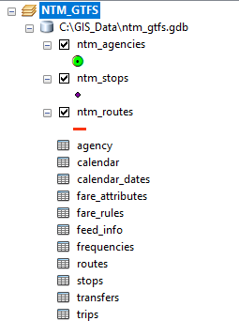

ntm_gtfs GeoDB schema:

See the attached file: ntm_gtfs_ExportXMLWorkspace.xml

## General Transit Feed Specification (GTFS) Reference:

See the attached files: GTFS_Spec_Short.json and GTFS_Spec_Short.csv

<https://gtfs.org/reference/static/#term-definitions>

**Instructions for Preparing the NTM Services from the Updated NTM GeoDB Layers and Tables:**

## **NTM/ntm_agency_classifications (MapServer)**

**Service Description:** These layers describe transit agencies according to their Tribal, Urban, Rural, USDOT Region, and National Transit Database Classifications.

**Map Name:** Transit Layers

**Layers:**

* [Tribal Agencies](https://maps.bts.dot.gov/services/rest/services/NTM/ntm_agency_classifications/MapServer/0) (0)
* [Urban Agencies](https://maps.bts.dot.gov/services/rest/services/NTM/ntm_agency_classifications/MapServer/1) (1)
* [Rural Agencies](https://maps.bts.dot.gov/services/rest/services/NTM/ntm_agency_classifications/MapServer/2) (2)
* [Agencies by Region](https://maps.bts.dot.gov/services/rest/services/NTM/ntm_agency_classifications/MapServer/3) (3)
* [National Transit Database](https://maps.bts.dot.gov/services/rest/services/NTM/ntm_agency_classifications/MapServer/4) (4)
* [Metropolitan Planning Organizations](https://maps.bts.dot.gov/services/rest/services/NTM/ntm_agency_classifications/MapServer/5) (5)

**Document Info:**

Title: NTM Agency Classification  
Author:  
Comments: These layers describe transit agencies according to their Tribal, Urban, Rural, USDOT Region, and National Transit Database Classifications.  
Subject: Transit agencies classified as Tribal, Urban, or Rural. Also includes USDOT Region, and National Transit Database classifications.  
Category:  
Keywords: Transit,National,Map,VOMS  
AntialiasingMode: None  
TextAntialiasingMode: Force

Layers 0-2 are subsets of ntm_agencies based on the field of **Reporting_Module**:

* [Tribal Agencies](https://maps.bts.dot.gov/services/rest/services/NTM/ntm_agency_classifications/MapServer/0) (0)
* [Urban Agencies](https://maps.bts.dot.gov/services/rest/services/NTM/ntm_agency_classifications/MapServer/1) (1)
* [Rural Agencies](https://maps.bts.dot.gov/services/rest/services/NTM/ntm_agency_classifications/MapServer/2) (2)

For example:

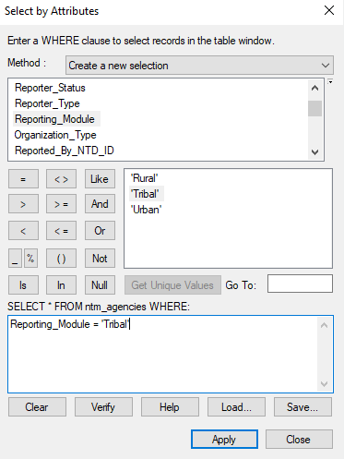

Save the selected features to: **Tribal Agencies**

Repeat the same steps above to generate: **Urban Agencies**

and **Rural Agencies**

Reporting_Module = 'Urban'

Reporting_Module = 'Rural'

Layer 3 is the entire ntm_agencies based on the field of **Region**:

* [Agencies by Region](https://maps.bts.dot.gov/services/rest/services/NTM/ntm_agency_classifications/MapServer/3) (3)

Just save the ntm_agencies to a new layer with the name of: **Agencies by Region**

Layer 4 is the entire ntm_agencies:

* [National Transit Database](https://maps.bts.dot.gov/services/rest/services/NTM/ntm_agency_classifications/MapServer/4) (4)

Just save the ntm_agencies to a new layer with the name of: **National Transit Database**

Layer 5 is not updated and the old one still can be used.

* [Metropolitan Planning Organizations](https://maps.bts.dot.gov/services/rest/services/NTM/ntm_agency_classifications/MapServer/5) (5)

## **NTM/ntm_gtfs (MapServer)**

**Service Description:** GTFS Data stored in the National Transit Map database. GTFS Specification: <https://developers.google.com/transit/gtfs/reference/>

**Layers:**

* [**stops**](https://maps.bts.dot.gov/services/rest/services/NTM/ntm_gtfs/MapServer/0) **(0)**
* [**shapes**](https://maps.bts.dot.gov/services/rest/services/NTM/ntm_gtfs/MapServer/1) **(1)**

**Tables:**

* [**agency**](https://maps.bts.dot.gov/services/rest/services/NTM/ntm_gtfs/MapServer/2) **(2)**
* [**routes**](https://maps.bts.dot.gov/services/rest/services/NTM/ntm_gtfs/MapServer/3) **(3)**
* [**trips**](https://maps.bts.dot.gov/services/rest/services/NTM/ntm_gtfs/MapServer/4) **(4)**
* [**calendar**](https://maps.bts.dot.gov/services/rest/services/NTM/ntm_gtfs/MapServer/5) **(5)**
* [**calendar_dates**](https://maps.bts.dot.gov/services/rest/services/NTM/ntm_gtfs/MapServer/6) **(6)**
* [**fare_attributes**](https://maps.bts.dot.gov/services/rest/services/NTM/ntm_gtfs/MapServer/7) **(7)**
* [**fare_rules**](https://maps.bts.dot.gov/services/rest/services/NTM/ntm_gtfs/MapServer/8) **(8)**
* [**frequencies**](https://maps.bts.dot.gov/services/rest/services/NTM/ntm_gtfs/MapServer/9) **(9)**
* [**transfers**](https://maps.bts.dot.gov/services/rest/services/NTM/ntm_gtfs/MapServer/10) **(10)**
* [**feed_info**](https://maps.bts.dot.gov/services/rest/services/NTM/ntm_gtfs/MapServer/11) **(11)**

**Document Info:**

Title: GTFS Source Data  
Author:  
Comments: GTFS Data stored in the National Transit Map database. GTFS Specification: https://developers.google.com/transit/gtfs/reference/  
Subject: GTFS Data stored in the National Transit Map database.  
Category:  
Keywords: Transit,Stops,Route,Shapes  
AntialiasingMode: None  
TextAntialiasingMode: ForceSupports Dynamic Layers: true

Layer 0 is the entire ntm_stops:

* [**stops**](https://maps.bts.dot.gov/services/rest/services/NTM/ntm_gtfs/MapServer/0) **(0)**

Just save the ntm_stops to a new layer with the name of: **stops**

Layer 1 is the entire ntm_routes:

* [**shapes**](https://maps.bts.dot.gov/services/rest/services/NTM/ntm_gtfs/MapServer/1) **(1)**

Just save the ntm_routes to a new layer with the name of: **shapes**

10 tables are the same as the updated tables, you don't need to change names.

**Note:** One additional field is added to the updated tables: ntd_id which old ones didn’t have.

## **NTM/ntm_participation (MapServer)**

**Service Description:**

**Map Name:** Transit Layers

**Layers:**

* [NTM Participation](https://maps.bts.dot.gov/services/rest/services/NTM/ntm_participation/MapServer/0) (0)
  + [Participating](https://maps.bts.dot.gov/services/rest/services/NTM/ntm_participation/MapServer/1) (1)
  + [Declined](https://maps.bts.dot.gov/services/rest/services/NTM/ntm_participation/MapServer/2) (2)
  + [Not Yet Contacted](https://maps.bts.dot.gov/services/rest/services/NTM/ntm_participation/MapServer/3) (3)

**Document Info:**

Title: Nataional Transit Map Participation  
Author:  
Comments: These layers describe which transit agencies are participation in the National Transit Map.  
Subject: These layers describe which transit agencies are participation in the National Transit Map.  
Category:  
Keywords: Transit,National,Map,VOMS  
AntialiasingMode: None  
TextAntialiasingMode: Force**Supports Dynamic Layers:** true

Layer 0 is the entire ntm_agencies:

* [NTM Participation](https://maps.bts.dot.gov/services/rest/services/NTM/ntm_participation/MapServer/0) (0)

Just save the ntm_agencies to a new layer with the name of: [NTM Participation](https://maps.bts.dot.gov/services/rest/services/NTM/ntm_participation/MapServer/0)

Layers 1-3 are subsets of the [NTM Participation](https://maps.bts.dot.gov/services/rest/services/NTM/ntm_participation/MapServer/0) based on the field of: **NTMParticipation**

For example:

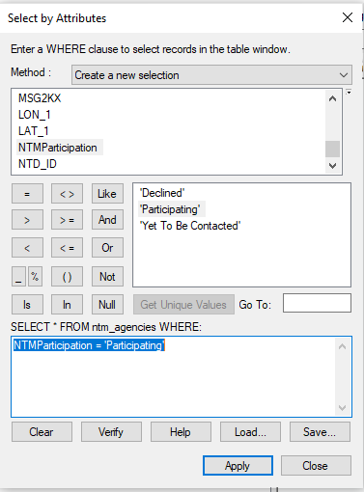

Just save the selected features to a new layer with the name of: [Participating](https://maps.bts.dot.gov/services/rest/services/NTM/ntm_participation/MapServer/1)

Repeat the same steps above to generate other two layers: [Declined](https://maps.bts.dot.gov/services/rest/services/NTM/ntm_participation/MapServer/2) and [Not Yet Contacted](https://maps.bts.dot.gov/services/rest/services/NTM/ntm_participation/MapServer/3)

* + [Declined](https://maps.bts.dot.gov/services/rest/services/NTM/ntm_participation/MapServer/2) (2)
  + [Not Yet Contacted](https://maps.bts.dot.gov/services/rest/services/NTM/ntm_participation/MapServer/3) (3)

NTMParticipation = 'Declined'

NTMParticipation = 'Yet To Be Contacted'

## **NTM/ntm_stops_routes_bounds_buffers (MapServer)**

**Service Description:** National Transit Map Stops, Route Shapes, and Minimum Bounding Boxes

**Layers:**

* [Agency Service Bounds](https://maps.bts.dot.gov/services/rest/services/NTM/ntm_stops_routes_bounds_buffers/MapServer/0) (0)
* [Stops and Stations](https://maps.bts.dot.gov/services/rest/services/NTM/ntm_stops_routes_bounds_buffers/MapServer/1) (1)
  + [Transit Station Entrance/Exit](https://maps.bts.dot.gov/services/rest/services/NTM/ntm_stops_routes_bounds_buffers/MapServer/2) (2)
  + [Transit Stops](https://maps.bts.dot.gov/services/rest/services/NTM/ntm_stops_routes_bounds_buffers/MapServer/3) (3)
  + [Transit Stations](https://maps.bts.dot.gov/services/rest/services/NTM/ntm_stops_routes_bounds_buffers/MapServer/4) (4)
  + [All Transit Stops](https://maps.bts.dot.gov/services/rest/services/NTM/ntm_stops_routes_bounds_buffers/MapServer/5) (5)
* [Routes](https://maps.bts.dot.gov/services/rest/services/NTM/ntm_stops_routes_bounds_buffers/MapServer/6) (6)
  + [Gondola Routes](https://maps.bts.dot.gov/services/rest/services/NTM/ntm_stops_routes_bounds_buffers/MapServer/7) (7)
  + [Ferry Routes](https://maps.bts.dot.gov/services/rest/services/NTM/ntm_stops_routes_bounds_buffers/MapServer/8) (8)
  + [Cable Car Routes](https://maps.bts.dot.gov/services/rest/services/NTM/ntm_stops_routes_bounds_buffers/MapServer/9) (9)
  + [Tram Routes](https://maps.bts.dot.gov/services/rest/services/NTM/ntm_stops_routes_bounds_buffers/MapServer/10) (10)
  + [Express Bus Routes](https://maps.bts.dot.gov/services/rest/services/NTM/ntm_stops_routes_bounds_buffers/MapServer/11) (11)
  + [Trolley Bus Routes](https://maps.bts.dot.gov/services/rest/services/NTM/ntm_stops_routes_bounds_buffers/MapServer/12) (12)
  + [Unclassified Routes](https://maps.bts.dot.gov/services/rest/services/NTM/ntm_stops_routes_bounds_buffers/MapServer/13) (13)
  + [Street Car Routes](https://maps.bts.dot.gov/services/rest/services/NTM/ntm_stops_routes_bounds_buffers/MapServer/14) (14)
  + [Subway / Metro Routes](https://maps.bts.dot.gov/services/rest/services/NTM/ntm_stops_routes_bounds_buffers/MapServer/15) (15)
  + [Rail Routes](https://maps.bts.dot.gov/services/rest/services/NTM/ntm_stops_routes_bounds_buffers/MapServer/16) (16)
  + [Bus Routes](https://maps.bts.dot.gov/services/rest/services/NTM/ntm_stops_routes_bounds_buffers/MapServer/17) (17)
  + [All Transit Route Shapes](https://maps.bts.dot.gov/services/rest/services/NTM/ntm_stops_routes_bounds_buffers/MapServer/18) (18)
* [Metropolitan Planning Organizations](https://maps.bts.dot.gov/services/rest/services/NTM/ntm_stops_routes_bounds_buffers/MapServer/19) (19)

**Document Info:**

Title: NTM Stops, Routes, Bounds, and Buffers  
Author:  
Comments: National Transit Map Stops, Route Shapes, and Minimum Bounding Boxes  
Subject: National Transit Map Stops, Route Shapes, and Minimum Bounding Boxes  
Category:  
Keywords: Transit,Stops,Route,Shapes  
AntialiasingMode: None  
TextAntialiasingMode: Force**Supports Dynamic Layers:** true

Layers 0and 19 are not changed, the old ones still can be used.

Layers 2-5 are extracted from the ntm_stops based on the field of:  **location_type**

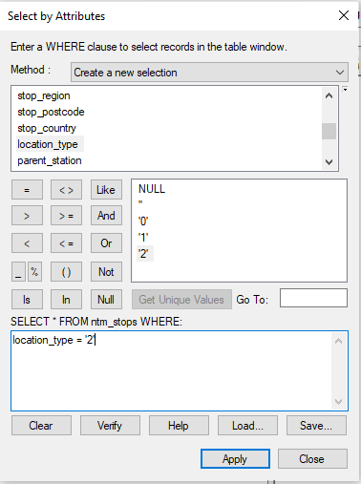

Layer 2 is a subset of ntm_stops with entrances/exits (location_type=2):

* + [Transit Station Entrance/Exit](https://maps.bts.dot.gov/services/rest/services/NTM/ntm_stops_routes_bounds_buffers/MapServer/2) (2)

Layer 3 is a subset of ntm_stops with stops (location_type=0):

* + [Transit Stops](https://maps.bts.dot.gov/services/rest/services/NTM/ntm_stops_routes_bounds_buffers/MapServer/3) (3)

Layer 4 is a subset of ntm_stops with stations (location_type=1):

* + [Transit Stations](https://maps.bts.dot.gov/services/rest/services/NTM/ntm_stops_routes_bounds_buffers/MapServer/4) (4)

Layer 5 is the entire ntm_stops, just save it to a new layer with the name of: [All Transit Stops](https://maps.bts.dot.gov/services/rest/services/NTM/ntm_stops_routes_bounds_buffers/MapServer/5)

Layers 7-18 are subsets of ntm_routes based on the field of: **route_type**

For example:

Layer 16 is a subset of ntm_routes with **route_type=2:**

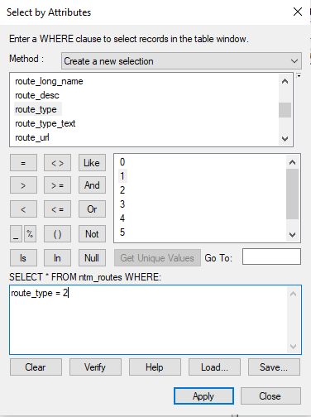

Save the selected features to a new layer with the name of: [Rail Routes](https://maps.bts.dot.gov/services/rest/services/NTM/ntm_stops_routes_bounds_buffers/MapServer/16)

Repeat the same steps above to generate other layers related to routes:

Indicates the type of transportation used on a route. Valid options are:

0 - Tram, Streetcar, Light rail. Any light rail or street level system within a metropolitan area.

1 - Subway, Metro. Any underground rail system within a metropolitan area.

2 - Rail. Used for intercity or long-distance travel.

3 - Bus. Used for short- and long-distance bus routes.

4 - Ferry. Used for short- and long-distance boat service.

5 - Cable tram. Used for street-level rail cars where the cable runs beneath the vehicle, e.g., cable car in San Francisco.

6 - Aerial lift, suspended cable car (e.g., gondola lift, aerial tramway). Cable transport where cabins, cars, gondolas or open chairs are suspended by means of one or more cables.

7 - Funicular. Any rail system designed for steep inclines.

## **NTM/ntm_VOMS (MapServer)**

**Service Description:** These layers describe transit agencies by the number of Vehicles they Operate at Maximum Service. They are categorized as Tribal, Rural, and Urban

**Map Name:** Transit Layers

**Layers:**

* [Total VOMS - Tribal Agencies](https://maps.bts.dot.gov/services/rest/services/NTM/ntm_VOMS/MapServer/0) (0)
* [Total VOMS - Rural Agencies](https://maps.bts.dot.gov/services/rest/services/NTM/ntm_VOMS/MapServer/1) (1)
* [Total VOMS - Urban Agencies](https://maps.bts.dot.gov/services/rest/services/NTM/ntm_VOMS/MapServer/2) (2)
* [Total VOMS - All Agencies](https://maps.bts.dot.gov/services/rest/services/NTM/ntm_VOMS/MapServer/3) (3)

**Document Info:**

Title: NTM Vehicles Operated at Maximum Service  
Author:  
Comments: These layers describe transit agencies by the number of Vehicles they Operate at Maximum Service. They are categorized as Tribal, Rural, and Urban  
Subject: Transit agencies by the number of Vehicles they Operate at Maximum Service.  
Category:  
Keywords: Transit,National,Map,VOMS  
AntialiasingMode: None  
TextAntialiasingMode: Force**Supports Dynamic Layers:** true

The layers above can be generated from the layers in from **NTM/ntm_agency_classifications (MapServer)**

Based on the field of: **Total_VOMS**

**ntm_stop_times.csv**

### stop_times.txt

File: Required

|  |  |  |  |
| --- | --- | --- | --- |
| **Field Name** | **Type** | **Required** | **Description** |
| trip_id | ID referencing trips.trip_id | Required | Identifies a trip. |
| arrival_time | Time | Conditionally required | Arrival time at a specific stop for a specific trip on a route. If there are not separate times for arrival and departure at a stop, enter the same value for arrival_time and departure_time. For times occurring after midnight on the service day, enter the time as a value greater than 24:00:00 in HH:MM:SS local time for the day on which the trip schedule begins.  Scheduled stops where the vehicle strictly adheres to the specified arrival and departure times are timepoints. If this stop is not a timepoint, it is recommended to provide an estimated or interpolated time. If this is not available, arrival_time can be left empty. Further, indicate that interpolated times are provided with timepoint=0. If interpolated times are indicated with timepoint=0, then time points must be indicated with timepoint=1. Provide arrival times for all stops that are time points. An arrival time must be specified for the first and the last stop in a trip. |
| departure_time | Time | Conditionally required | Departure time from a specific stop for a specific trip on a route. For times occurring after midnight on the service day, enter the time as a value greater than 24:00:00 in HH:MM:SS local time for the day on which the trip schedule begins. If there are not separate times for arrival and departure at a stop, enter the same value for arrival_time and departure_time. See the arrival_time description for more details about using timepoints correctly.  The departure_time field should specify time values whenever possible, including non-binding estimated or interpolated times between timepoints. |
| stop_id | ID referencing stops.stop_id | Required | Identifies the serviced stop. All stops serviced during a trip must have a record in [stop_times.txt](https://gtfs.org/reference/static/#stop_timestxt). Referenced locations must be stops, not stations or station entrances. A stop may be serviced multiple times in the same trip, and multiple trips and routes may service the same stop. |
| stop_sequence | Non-negative integer | Required | Order of stops for a particular trip. The values must increase along the trip but do not need to be consecutive.*Example: The first location on the trip could have a stop_sequence=1, the second location on the trip could have a stop_sequence=23, the third location could have a stop_sequence=40, and so on.* |
| stop_headsign | Text | Optional | Text that appears on signage identifying the trip's destination to riders. This field overrides the default trips.trip_headsign when the headsign changes between stops. If the headsign is displayed for an entire trip, use trips.trip_headsign instead.  A stop_headsign value specified for one stop_time does not apply to subsequent stop_times in the same trip. If you want to override the trip_headsign for multiple stop_times in the same trip, the stop_headsign value must be repeated in each stop_time row. |
| pickup_type | Enum | Optional | Indicates pickup method. Valid options are:  0 or empty - Regularly scheduled pickup.  1 - No pickup available.  2 - Must phone agency to arrange pickup.  3 - Must coordinate with driver to arrange pickup. |
| drop_off_type | Enum | Optional | Indicates drop off method. Valid options are:  0 or empty - Regularly scheduled drop off.  1 - No drop off available.  2 - Must phone agency to arrange drop off.  3 - Must coordinate with driver to arrange drop off. |
| shape_dist_traveled | Non-negative float | Optional | Actual distance traveled along the associated shape, from the first stop to the stop specified in this record. This field specifies how much of the shape to draw between any two stops during a trip. Must be in the same units used in [shapes.txt](https://gtfs.org/reference/static/#shapestxt). Values used for shape_dist_traveled must increase along with stop_sequence; they cannot be used to show reverse travel along a route.*Example: If a bus travels a distance of 5.25 kilometers from the start of the shape to the stop,shape_dist_traveled=5.25.* |
| timepoint | Enum | Optional | Indicates if arrival and departure times for a stop are strictly adhered to by the vehicle or if they are instead approximate and/or interpolated times. This field allows a GTFS producer to provide interpolated stop-times, while indicating that the times are approximate. Valid options are:  0 - Times are considered approximate.  1 or empty - Times are considered exact. |